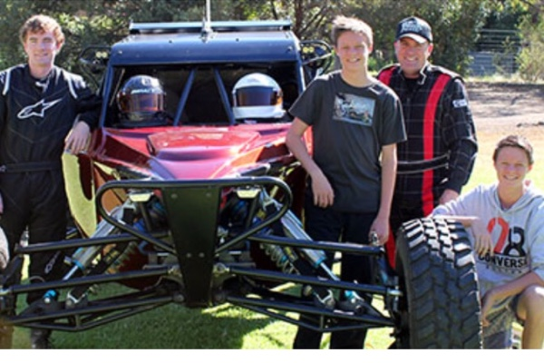

[10](https://www.gofundme.com/2dz99hvz)

# Adrian Lucey Fundraiser Evening

**Sunraysia Cellar Door - Saturday September 10th 2016 @ 6.30-9.30pm**  
Adrian was critically injured in a buggy accident at the Finke Desert Race on Sat 11th June 2016. Adrian is still in a serious but stable condition.  At this stage no one can really comprehend what lies ahead but acknowledge it will be difficult and costly for the Lucey family. A fundraiser and auction evening will be held at the Sunraysia Cellar Door on Saturday September 10th 2016. All funds raised on the evening will go directly to Luce’s family to assist with his rehabilitation.

**$50.00 entry fee – Includes Gourmet Finger Food, your 1st drink free on arrival, raffle prizes and $25 which goes directly to the family.**

**Auction Items**

3 nights/5 days on Luxury 12 berth Houseboat - Valued @ $2750+

1 x Geelong & 1 x Hawthorn fully signed & framed player’s jerseys – valued @ $500 each+

Tuna Fishing Charter for 8 people Port McDonald SA – valued @ $2000+

Navara extreme HID driving lights – valued @ $620

Moontongue Eco Kayak Adventure for 10 people

Valued @ $300.

If you are unable to attend the evening but wish to donate, please visit [www.gofundme.com](http://www.gofundme.com) and search (Adrian Lucey)